**gDivision of Electrical and Electronic Engineering**

**Analogue and Digital Electronics**

**(4EJ500)**

**Assignment 1(Lab Book)**

**Analogue Electronics –**

**Characteristics of Basic Semiconductor Devices**

**Programme(s): BEng Electrical & Electronic Engineering**

**BSc Electrical & Electronic Engineering**

**FdEng Electrical & Electronic Engineering**

**BSc Sound, Light & Live Event Technology**

**Assessment Number: 1 of 2**

College of Engineering and Technology

**Assessment Weighting: 30% of module**

**Learning Outcomes Assessed: 1**

**Module Leader: David Wilson**

[**D.Wilson@Derby.ac.uk**](mailto:D.Wilson@Derby.ac.uk)

**MS225**

**X3202**



|  |  |
| --- | --- |
| **D3000** | **Semiconductors-1** |
| Laboratory Manual | **Chapter 1** |

The following experiments use the D3000 2.1 Semiconductors-1 board.

# Exercise 1.1 Diode Forward Characteristic

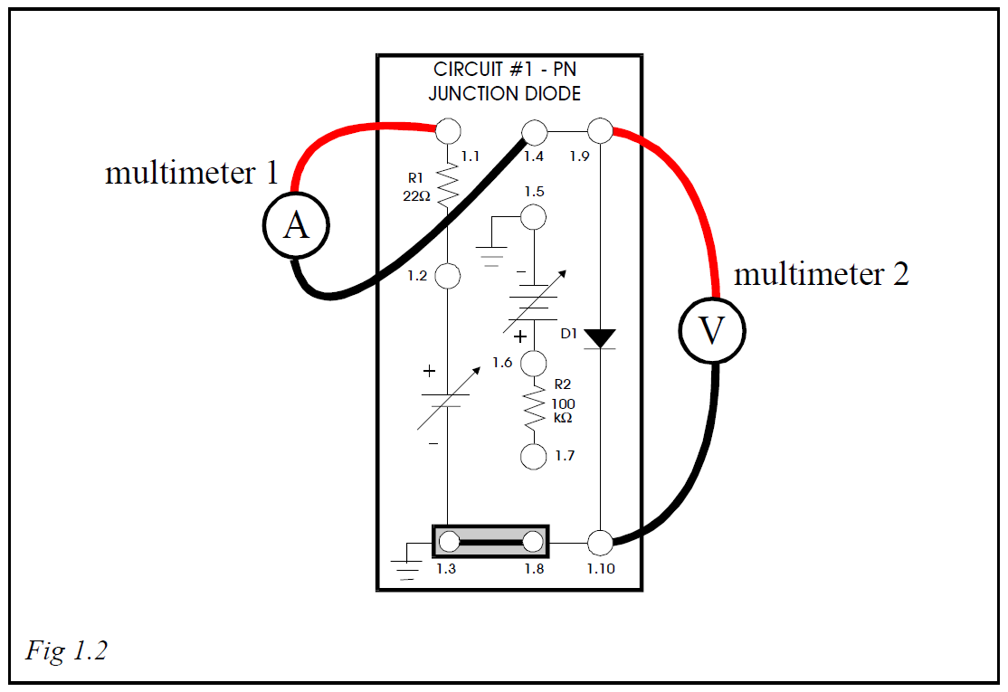

* Locate the 0-2V DC supply (blue potentiometer on the right hand side of the board) and turn the control to MIN.
* Connect a shorting link between sockets 1.3 & 1.8, as shown in Fig 1.2 above.
* Connect the ammeter on the mA DC range to sockets 1.1 (positive) and 1.4 (common), using 2-4mm adaptor plugs.
* Connect the digital voltmeter on the DC mV or V ranges (as applicable) to sockets 1.9 (positive) and 1.10 (common), using 2-4mm adaptor plugs.
* Switch ON the Module Power Supplies.
* Adjust the 0-2V supply to give 100mV across the diode.

|  |  |
| --- | --- |
| **D3000** | **Semiconductors-1** |
| Laboratory Manual | **Chapter 1** |

* Read the current from the ammeter and enter in Table 1.1.
* Reset the voltage to 200mV and repeat the current reading.
* Continue taking readings at the voltages indicated in Table 1.1, noting that the interval is changed to 50mV as soon as the current starts increasing rapidly. Watch the current reading as the voltage is increased and change the range setting of the ammeter as required. Try to anticipate the need to change ranges in order to prevent damage to the instrument.

**Beware as you change ranges on the ammeter you will need to reset the voltage.**

(The reduced resistance of the ammeter on the higher current ranges will cause an increase of voltage across the diode).

|  |  |
| --- | --- |
| Voltage (mV) | Current |
| 100 (99.56) | 0 µA |
| 200 (199.96) | 0 µA |
| 300 (300.85) | 1 µA |
| 400 (399.91) | 8.6 µA |
| 500 (500.3) | 81.2 µA |
| 550 (549.2) | 219.8 µA |
| 600 (598.6) | 546.4 µA |
| 650 (648.7) | 1.73 mA |
| 700 (703.2) | 4.06 mA |
| 750 (751.4) | 9.80 mA |
| 800 (800.4) | 17.23 mA |
| 850 (849.5) | 27.45 mA |
| *Table 1.1* |  |

* Plot the forward characteristic of the diode on the axes provided. **Note that the low current readings are too small to be plotted.**

|  |  |
| --- | --- |
| **D3000** | **Semiconductors-1** |
| Laboratory Manual | **Chapter 1** |

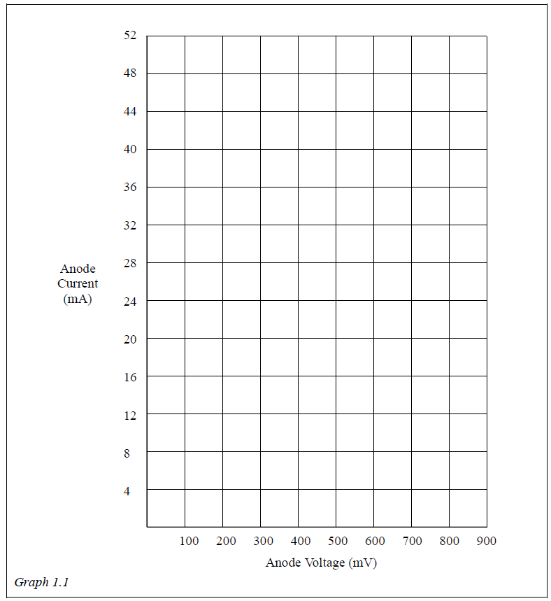

You will observe that the steps of current are not linear against voltage, showing that the diode does not follow Ohm's Law

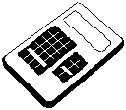**From your graph, read off the voltage dropped across the diode when the anode current is 12mA and enter in mV.**

mV

|  |  |
| --- | --- |
| **D3000** | **Semiconductors-1** |
| Laboratory Manual | **Chapter 1** |

# Exercise 1.2 Diode Reverse Characteristic

It is necessary to get the reverse bias current (leakage current) flow of the diode into proportion. For practical purposes this current is negligible. This is confirmed in the first part of the experiment. However the leakage current of a p-n junction can be significant in some semiconductors, so it is worth spending a little extra time investigating this more carefully.

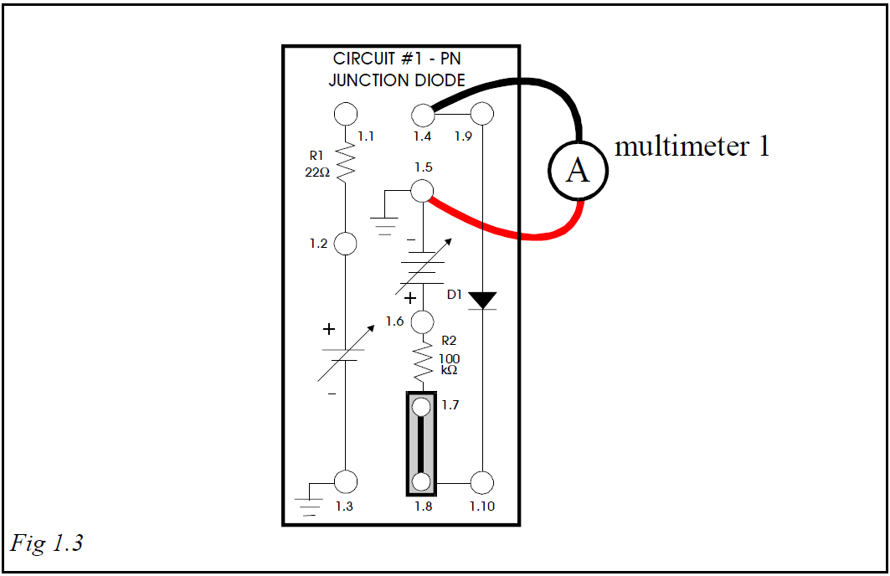

* Plug a shorting link between sockets 1.7 & 1.8.
* Connect the ammeter on the mA DC range between sockets 1.5 (positive) and 1.4 (common).
* Set the main 0-12V Variable DC supply control on the Base Unit to the MIN (0V) position and switch ON the Module Power Supplies.

**Note**: The main 0-12V DC variable power supply is connected with its negative terminal uppermost, so that the diode can be conveniently reverse biased using shorting links.

|  |  |
| --- | --- |
| **D3000** | **Semiconductors-1** |
| Laboratory Manual | **Chapter 1** |

* Watch the ammeter as the main 0-12V DC variable supply is increased to maximum.

You will note that there is no response, indicating that the current is of negligibly small proportions. However, we know that there is a small amount of minority carrier current, and R2 has been included in circuit so that monitoring the voltage dropped across it will allow the leakage current to be determined.

* Remove the ammeter from the circuit and replace it by a shorting link between sockets 1.4 & 1.5.
* Connect the voltmeter on the DC Voltage range to sockets 1.9 (positive) and 1.10 (common), to measure the anode voltage of diode D1 with respect to the cathode. Adjust the variable supply until the measured anode voltage is -1V.

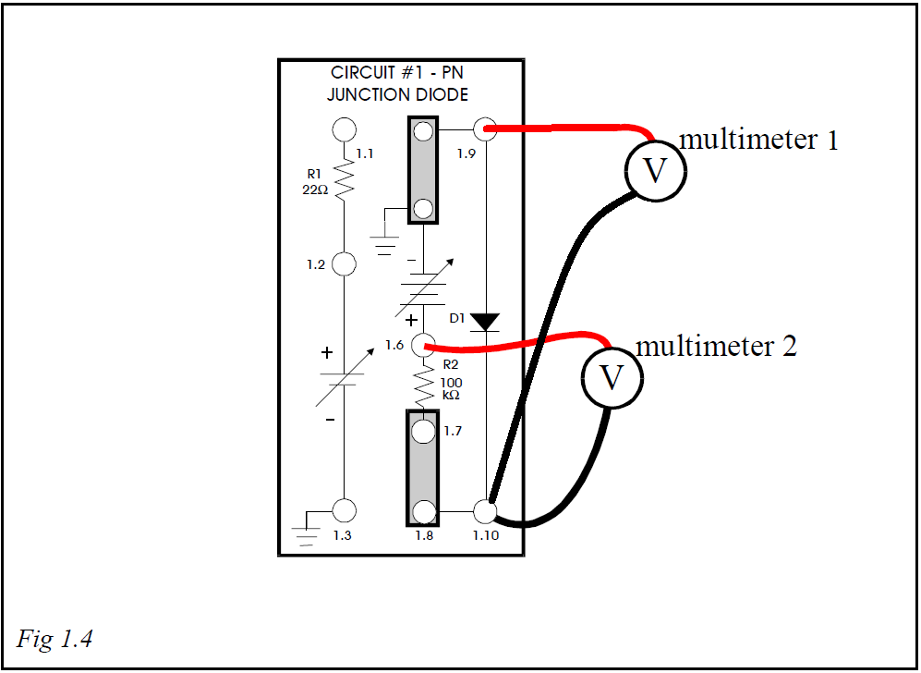

* Reconnect the voltmeter on the mV DC range to sockets 1.6 (positive) and 1.10 (common), as shown in Fig 1.4. Record the potential difference (voltage) across R2 (in mV) in Table 1.2 overleaf.

|  |  |
| --- | --- |
| **D3000** | **Semiconductors-1** |
| Laboratory Manual | **Chapter 1** |

* Repeat the previous two steps for anode voltages of -2V, -3V, and so on, up to -12V.

**Note**: Because the voltage across R2 is so very small (probably less than 1µV) the meter may have difficulty in giving a steady reading when measuring across R2. If you encounter this difficulty you should take the average of the highest and lowest indications and record that value.

|  |  |  |
| --- | --- | --- |
| Anode Voltage (V) | Voltage across R  (mV) | Leakage Current |
| -1 (-0.9998) | 9.13 | nA |
| -2 (-2.0010) | 18.01 | nA |
| -3 (-3.0060) | 26.92 | nA |
| -4 (-3.9998) | 35.71 | nA |
| -5 (-5.0080) | 49.07 | nA |
| -6 (-6.0040) | 58.77 | nA |
| -7(-6.9950) | 68.43 | nA |
| -8 (8.0040) | 78.21 | nA |
| -9 (-9.007) | 88.48 | nA |
| -10(-10.003) | 97.80 | nA |
| -11(-10.998) | 107.38 | nA |
| -12(-12.004) | 117.18 | nA |
| *Table 1.2* |  |  |

The value of the leakage current can now be calculated by dividing the voltage across R2 by the value of R2 (100k).

* Calculate the value of leakage current for each of the voltage steps and add to Table 1.2 above

I_leak = Vr2/r2 (100k)

|  |  |
| --- | --- |
| **D3000** | **Semiconductors-1** |
| Laboratory Manual | **Chapter 4** |

# Exercise 4.1 Zener Diode Characteristic

The zener diode has a similar characteristic in forward bias to the PN junction diode examined in Chapter 1. The reverse characteristic, however, has been modified to allow current to flow above a pre-determined voltage.

The rise of current in the reverse direction is very rapid, giving the facility of a voltage stabilizing device at the zener voltage.

The object of this exercise is to plot the characteristic of a zener diode.

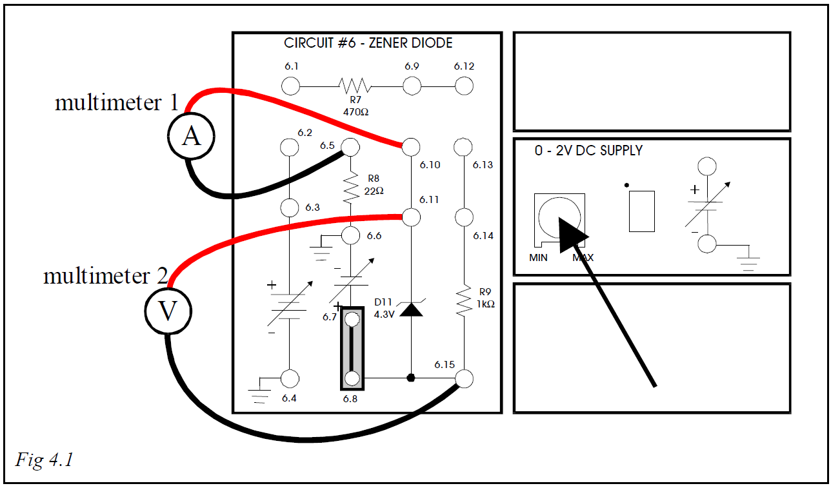

First, we will investigate the **Forward Bias** characteristic of the zener diode.

* Plug a shorting link between sockets 6.7 & 6.8, as shown in Fig 4.1.
* Connect the ammeter on the mA DC range between sockets 6.5 (common) and 6.10 (positive).
* Connect the voltmeter on the DC Voltage range between sockets 6.11 and 6.15.
* Set the 0-2V DC supply (arrowed in Fig 4.1) to min.
* Switch ON the Module Power Supplies to power the 0-2V variable DC supply.

|  |  |
| --- | --- |
| **D3000** | **Semiconductors-1** |
| Laboratory Manual | **Chapter 4** |

* Vary the 0-2V supply from 0V to 0.5V (as indicated on the voltmeter) and note that there is negligible current registered on the ammeter over this range.
* Measure the current at voltages of 0.6V, 0.7V and 0.8V, changing the ammeter range up as necessary. Enter your results in Table 4.1 below:

|  |  |
| --- | --- |
| Voltage (V) (negative because of the way it’s connected) | Current (mA) |
| 0.6 (**-**0.60220) | 0.025 |
| 0.7(-0.6.998) | 0.48 |
| 0.8 (-0.7997) | 5.96 |
| *Table 4.1* |  |

We will now investigate the **Reverse Bias** characteristic of the zener diode.

* Remove the link between sockets 6.7 & 6.8.
* Set the 0-12V variable DC supply to the MIN (0V) position.
* Connect shorting links between sockets 6.1 & 6.2 and 6.4 & 6.8, as shown in Fig 4.2. 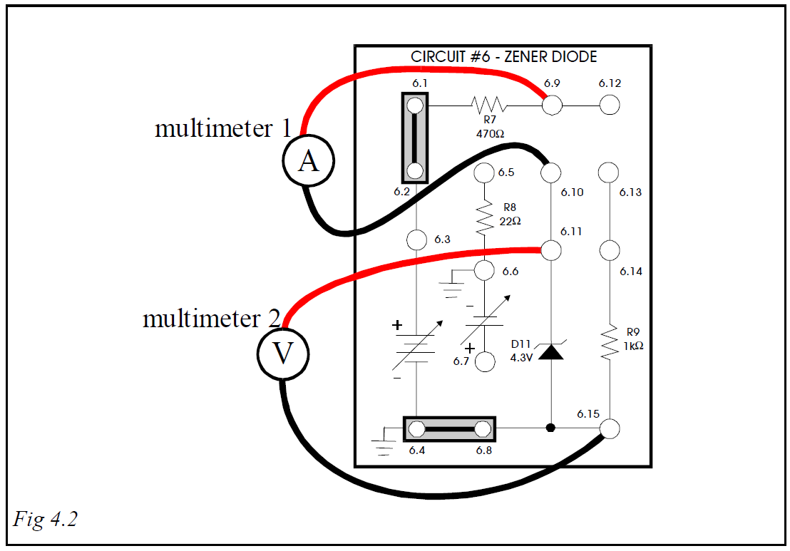

|  |  |
| --- | --- |
| **D3000** | **Semiconductors-1** |
| Laboratory Manual | **Chapter 4** |

* Connect the ammeter on the mA DC range between sockets 6.9 (positive) and 6.10 (common) to complete the circuit from the diode (now in Reverse Bias) to the 0-12V variable DC supply.
* Connect the voltmeter on the DC Voltage range between sockets 6.11 and 6.15 to monitor the reverse voltage across the diode.
* Switch ON the Module Power Supplies, and use the Variable DC Control to vary the voltage.
* Take readings of current at the voltages listed in Table 4.2, changing the ammeter range up when necessary:

|  |  |
| --- | --- |
| Voltage (V) | Current (mA) |
| 1V (0.9899) | 0.0084 |
| 2V (1.9987) | 0.0666 |
| 3V (3.0030) | 0.3660 |
| 4V (4.007) | 2.840 |
| 4.2V (4.201) | 4.79 |
| 4.4V (4.394) | 6.93 |
| 4.6V* (4.598) | 11.93 |
| *Table 4.2* |  |

* Due to the variation in characteristics between zener diodes, it may not always be possible to obtain a reverse voltage of 4.6V.

**Note**: These are negative voltages with respect to the diode, since the positive voltage is applied to the cathode. This is, however the mode in which the zener diode is operated as a voltage stabilizer.

|  |  |
| --- | --- |
| **D3000** | **Semiconductors-1** |
| Laboratory Manual | **Chapter 4** |

* From the information in Tables 4.1 & 4.2, plot the graph of current against voltage on the axes provided, with the Forward Bias characteristic in the first quadrant (top right) and the Reverse Bias characteristic in the third quadrant (bottom left)

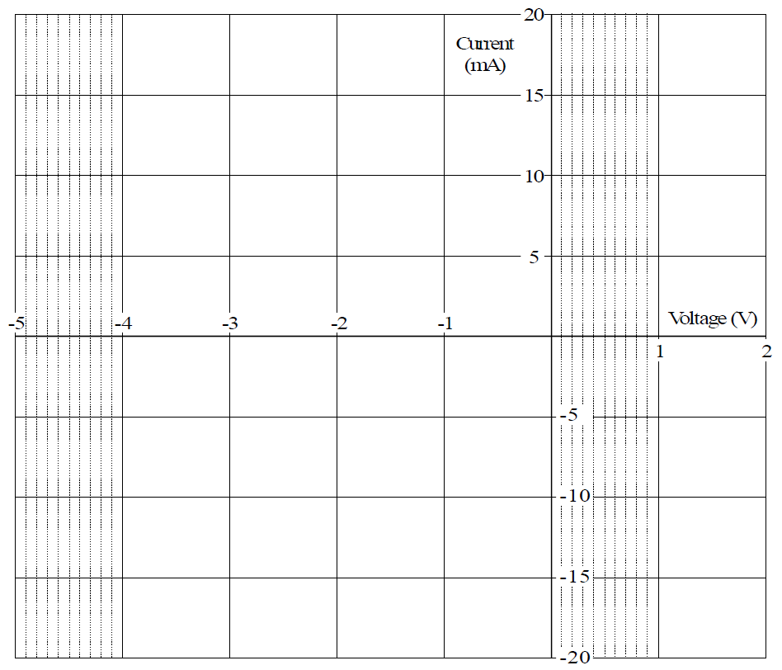

*Graph 4.1 Zener Diode Characteristic4.2*

|  |  |
| --- | --- |
| **D3000** | **Semiconductors-1** |
| Laboratory Manual | **Chapter 4** |

# Exercise 4.2 Zener Diode Stabilizer Currents

Kirchhoff's Law states that the total current flowing out of a junction equals the total current flowing in.

Since the voltage across a zener diode is constant, the voltage dropped across a series resistor will be constant if the supply voltage is constant. This means that the current in the series resistor (the supply current) will be constant.

The sum of currents flowing in the zener diode and the load will therefore be a constant value, equal to the supply current. Any increase of current in the load is matched by a reduction of the current flowing in the zener diode, and vice versa.

In this exercise you will investigate the currents flowing in the zener stabilizer circuit.

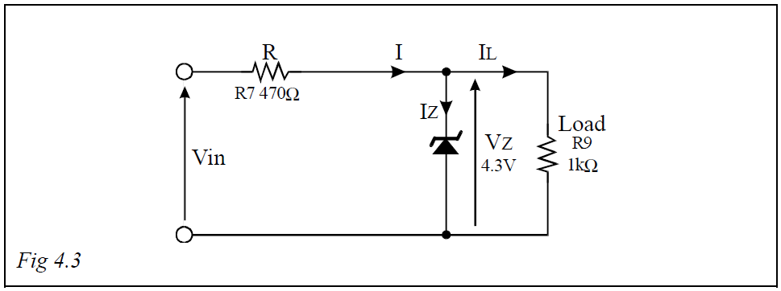

The load provided is 1kΩ, and the zener voltage (the voltage across the load) is 4.3V.

* Calculate the value of the expected current in the load, IL.

**4.2a Enter your calculated value of load current in mA. IL = Vz/Load = 4.3/1000 = 0.0043 A or 4.3mA**

mA

The supply current I will need to be greater than this by about 20% or more to give stabilization. **0.0043+ (0.0043*0.2) = 0.00516A or 5.16mA**

This current flows in the series resistor R in Fig 4.3 above, R7 (470Ω) in the circuit, generating a drop in voltage across it.

|  |  |
| --- | --- |
| **D3000** | **Semiconductors-1** |
| Laboratory Manual | **Chapter 4** |

Assuming a current, through the series resistor R, which is 20% greater than the load current IL, calculate the value of the voltage drop across R.

Vr = I*R = 0.00516*470 = 2.43V across resistor R

<https://www.mouser.co.uk/Semiconductors/Discrete-Semiconductors/Diodes-Rectifiers/Zener-Diodes/_/N-ax1mh?P=1yuq69z>

**4.2b Enter your calculated value of volt drop across series resistor R.**

If this is added to the zener voltage, the sum of the two voltages will be the required input voltage, Vin. Round this up to the next full volt above, and record:

Vs=Vr+Vz = 2.43+4.3 = 6.76 approx. 7V

**Vin =**

V

**Note:** Each of the vertical links in the diagram of Fig 4.4 carries one of the currents marked on the circuit diagram in Fig 4.3.

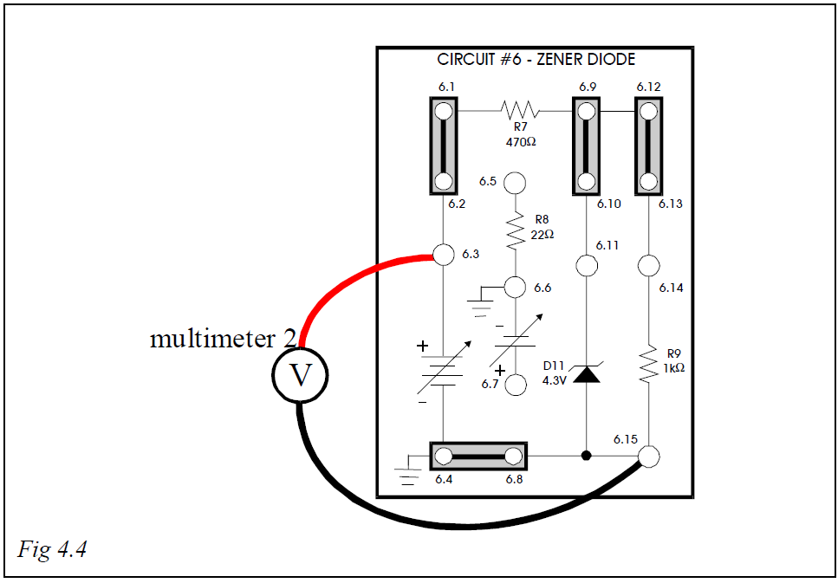

* Connect shorting links between sockets 6.1 & 6.2, 6.4 & 6.8, 6.9 & 6.10, and 6.12 & 6.13.
* Connect the voltmeter on the DC Voltage range between socket 6.3 and socket 6.15.
* Switch on the Module Power Supplies and set the 0-12V variable DC supply to the voltage which you have recorded above.

|  |  |
| --- | --- |
| **D3000** | **Semiconductors-1** |
| Laboratory Manual | **Chapter 4** |

* Measure each of the currents in turn by removing the relevant link and connecting the ammeter in its place. Record the currents in Table 4.5 below:

|  |  |  |  |
| --- | --- | --- | --- |
| Supply Current | Zener  Current | Load  Current | Sum of Load  & Zener Currents |
| 6.45mA | 2.2876 | 3.7852 | 6.0728mA |
| *Table 4.5* |  |  |  |

Compare the Supply Current with the sum of Load and Zener Currents and with your calculated figure of supply current above.

**Assumed current, 20% greater than iL, = 5.2mA**

**4.3/6.45 = 66.7% increase**

|  |  |
| --- | --- |
| **D3000** | **Semiconductors-1** |
| Laboratory Manual | **Chapter 5** |

# Exercise 5.1 Transistor Characteristics - Current Gain

**The static forward current transfer ratio** (ß or hFE), or **current gain, is calculated from the ratio**: 

The dynamic forward current transfer ratio (ß or hFE) is obtained from **changes** of base and collector currents. This is more useful when considering the effect on alternating or signal currents, which consist of continually changing values.

**Note**: The same symbol ß is used in both cases, but when using "h parameters" the suffix is in lower-case letters for the dynamic, and upper-case for the static ratio.

For instance, if a base current Ib1 results in a collector current Ic1, and a change of base current to Ib2 results in a new value of collector current Ic2, then the dynamic value of forward current gain (transfer ratio) is given by 

This can be taken as the same for either static (hFE, ß) or dynamic (or changing) values (hFE, ß).

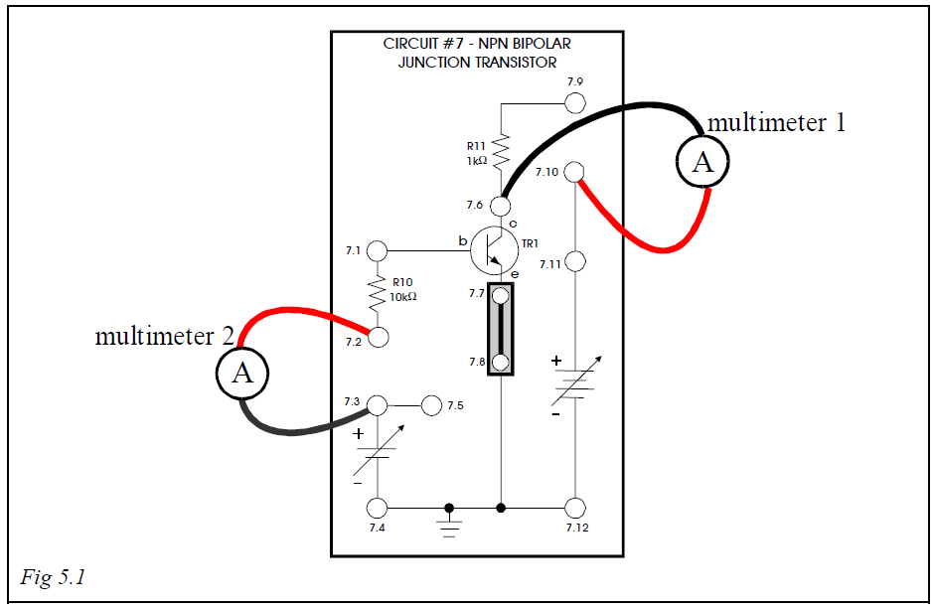

* Set the **0-2V DC SUPPLY** (upper right of module) to **MIN**.

|  |  |
| --- | --- |
| **D3000** | **Semiconductors-1** |
| Laboratory Manual | **Chapter 5** |

* Connect a shorting link between sockets 7.7 & 7.8 on Circuit #7.
* Connect the voltmeter on the DC Voltage range between sockets 7.11 (positive) and 7.12 common).
* Switch ON the Module Power Supplies.
* Set the 0-12V variable DC power supply to 5V. (4.999V)
* Disconnect the voltmeter from the circuit.
* Connect the ammeter on the mA DC range to sockets 7.3 (positive) and 7.2 (common).
* Connect the ammeter on the mA DC range to sockets 7.10 (positive) and 7.6 (common).
* Adjust the 0-2V DC supply to give a base current of 10µA.
* Note the value of the collector current and enter in Table 5.1:

|  |  |  |  |  |  |  |  |
| --- | --- | --- | --- | --- | --- | --- | --- |
| Base  Current | µA | Collector  Current | mA | Base  Current | µA | Collector  Current | mA |
| 10 (10.20) | | 3.04 | | 50 (49.50) | | 13.79 | |
| 20 (19.80) | | 5.74 | | 60 (60.20) | | 17.03 | |
| 30 (30.20) | | 8.56 | | 70 (69.8) | | 19.58 | |
| 40 (40.00) | | 11.43 | | 80 (80.00) | | 22.41 | |
| *Table 5.1* | |  | |  | |  | |

* Reset the 0-2V supply to give a base current of 20µA and take the reading of collector current. Enter in Table 5.1.
* Repeat adjustments and readings at steps of 10µA through 80µA, entering the corresponding collector current values in Table 5.1.
* Take as an example the case when Ib = 50µA. Calculate the value of the static forward current gain (transfer ratio) hFE or ß, by taking the ratio:

 (13.79*10-3)/(49.5*10-6) = 278.59

5.1a Enter your value of static forward current gain.

278.59

|  |  |
| --- | --- |
| **D3000** | **Semiconductors-1** |
| Laboratory Manual | **Chapter 5** |

* Plot the transfer characteristic, collector current/base current on the axes provided:

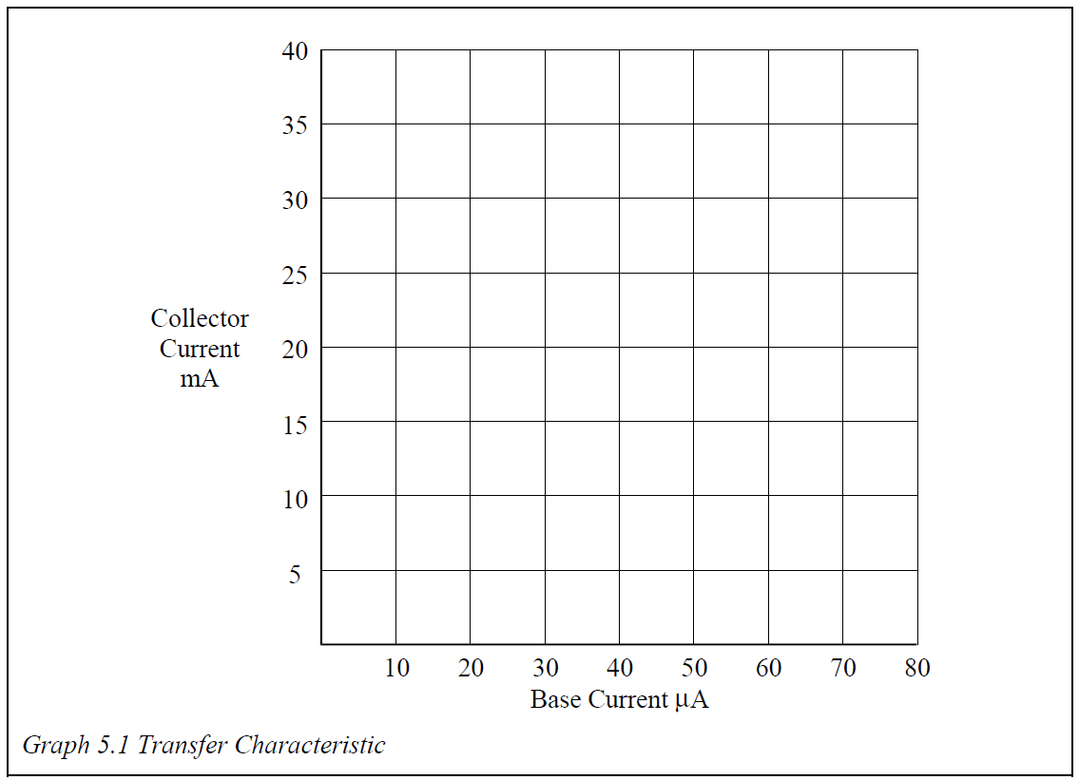

*Graph 5.1 Transfer Characteristic*

You should be able to draw a straight line through your plotted points indicating a linear relationship over this range of currents.

* Take as an example the range Ib = 20µA to Ib = 70µA. The change of base current (Ib) - where  means “a change of” - is given by (70µA-20µA) = 50µA.

Read from your table or graph the corresponding values of collector current Ic

**19.58-5.74=13.84**

Calculate Ic.

mA

The dynamic value of the forward current gain hFE, ß is given by:

(22.41-3.04)/(80-10.20) = 0.2775

$$\frac{}{}=\frac{δIc}{δIb}$$

|  |  |
| --- | --- |
| **D3000** | **Semiconductors-1** |
| Laboratory Manual | **Chapter 5** |

# Exercise 5.2 Transistor Output Characteristic

If the collector current was completely independent of the collector voltage then there would be no change in current as the voltage was varied, and the output characteristic would consist of a family of horizontal lines:

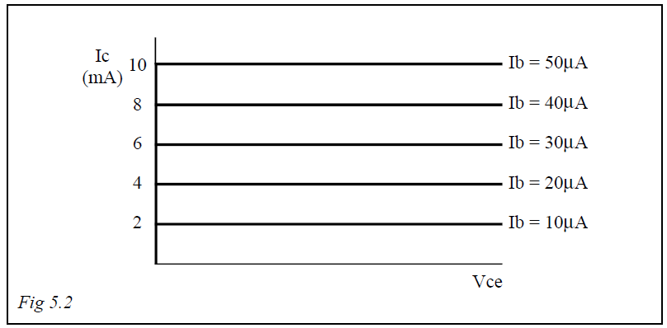

In practice this is not quite the case for two reasons:

* At higher values of input (base) current there is an increasing variation of output current with voltage, and
* At low values of collector voltage (Vce) the collector no longer attracts the free charge carriers in the base region and the collector current falls off very rapidly.

**Procedure**

There are three variables in this exercise, so one of them will have to be kept constant as a second is varied and the third is measured. Then the first will have to be changed and the adjustments and measurements repeated again - and again - etc.

You will find it easiest to keep the collector voltage constant, vary the base current through pre-defined values, and read off the collector current. Then change the collector voltage and repeat.

|  |  |
| --- | --- |
| **D3000** | **Semiconductors-1** |
| Laboratory Manual | **Chapter 5** |

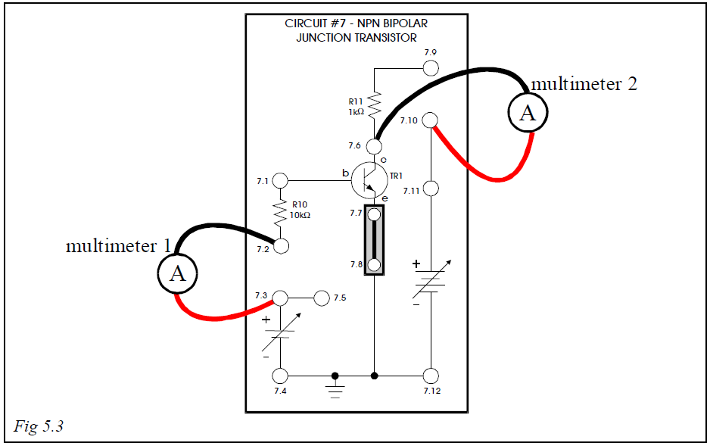

* Set the 0-2V DC Supply (upper right of module) to MIN.
* Connect a shorting link between sockets 7.7 & 7.8 on Circuit #7.
* Connect the voltmeter on the DC Voltage range between sockets 7.11 (positive) and 7.12 (common).
* Switch ON the Module Power Supplies.
* Set the 0-12V variable DC power supply to 1V.
* Disconnect the voltmeter from the circuit.
* Connect the ammeter on the mA DC range between sockets 7.10 (positive) and 7.6 (common).
* Connect the ammeter on the mA DC range between sockets 7.3 (positive) and 7.2 (common).
* Adjust the 0-2V DC supply to give a base current of 10µA.
* Note the value of the collector current and enter in Table 5.2 under the 1V heading and against 10µA base current.

|  |  |
| --- | --- |
| **D3000** | **Semiconductors-1** |
| Laboratory Manual | **Chapter 5** |

|  |  |  |  |  |
| --- | --- | --- | --- | --- |
| Base  Current | Collector Voltage | | | |
| 1V 0.9943 | 4V (4.0020) | 7V (6.993) | 10V (10.015) |
| 10µA (10.2) (9.6) (9.2) (10.4) | 2.89 mA | 2.77 | 2.74 | 3.12mA |
| 20µA (20.0) (19.8)(19.8) (20.2) | 5.62 mA | 5.63 | 5.83 | 6.33 |
| 30µA (28.2) (29.8) (29.8) (30.6) | 7.74 mA | 8.35 | 8.91 | 9.35mA |
| 40µA (38.4) (40.8) (40.2) (39.6) | 10.25mA | 11.48 | 11.64 | 11.94mA |
| 50µA (50.04) (49.8) (49.8) (49.4) | 13.12mA | 13.72 | 14.57 | 14.81 |
| *Table 5.2* |  |  |  |  |

* Reset the 0-2V supply to give a base current of 20µA and take the reading of collector current. Enter in Table 5.2, still under 1V.
* Repeat adjustments and readings at steps of 10µA through 50µA, entering the corresponding collector current values in Table 5.2 under 1V.
* Reduce the base current to 10µA and change the collector voltage to 4V (0-12V variable DC supply).
* Repeat all measurements of collector current at 10µA steps of base current, entering the results in Table 5.2 under the 4V heading.
* Repeat all steps again at collector voltages of 7V and then 10V, entering the results in the table as before.

**Note**: You may notice a tendency for the collector current value to creep up slowly at the highest settings. This is due to breaking of co-valent bonds at the higher temperature caused by the dissipation of power in the form of heat in the transistor.

**Reduce the variable controls to zero when these readings are completed, since the transistor may overheat if left for some time at these high voltages and currents.**

It is worth taking one set of readings at a base current of, for example, 30µA to find the shape of the characteristic at low voltages.

* Set the collector voltage to 0.2V (0-12V variable DC supply).

|  |  |
| --- | --- |
| **D3000** | **Semiconductors-1** |
| Laboratory Manual | **Chapter 5** |

* Set the base current to 30µA using the 0-2V variable supply.
* Read the value of the collector current and enter in Table 5.3 below.
* Repeat readings at steps of 0.2V through 1.0V, entering the results in Table 5.3.

|  |  |  |  |  |  |
| --- | --- | --- | --- | --- | --- |
| Collector Voltage | 0.2V 0.2032 | 0.4V 0.3998 | 0.6V  0.6002 | 0.8V  0.7998 | 1.0V  1.0007 |
| Collector Current (Ib =28.44 µA) | 1.85mA | 6.70 | 7.19 | 7.29 | 7.33 |

*Table 5.3*

* Plot the family of output characteristics, collector current against collector voltage, one for each value of base current on the axes provided:
* <http://www.dissidents.com/resources/LaboratoryManualForSemiconductorDevices.pdf>
* CBC549B I

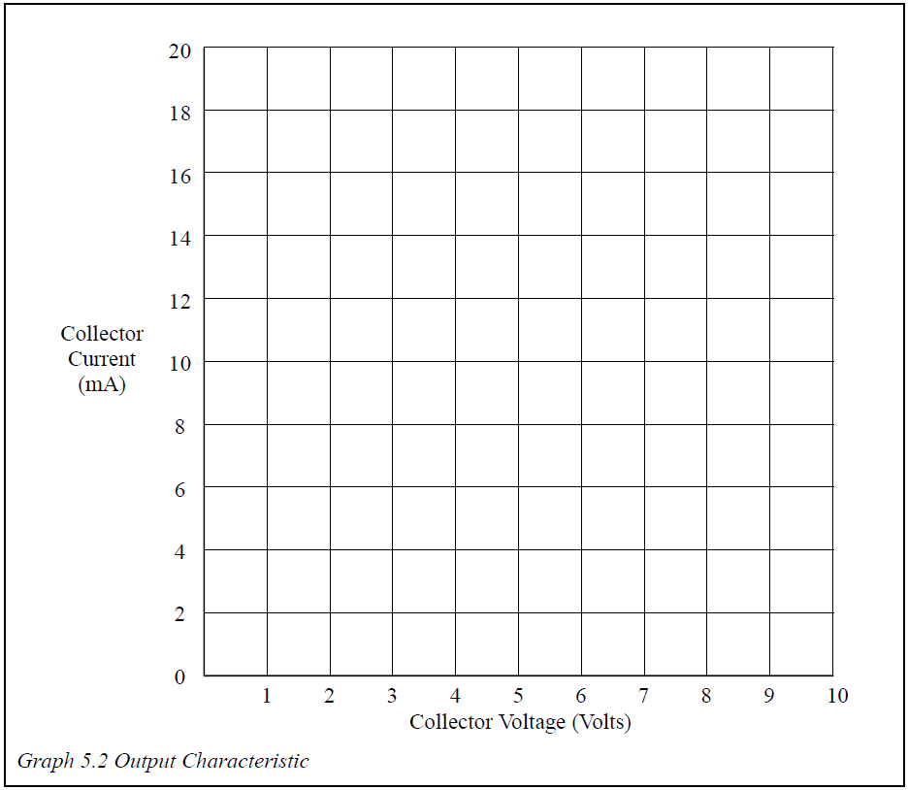

*Graph 5.2 Output Characteristic*

|  |  |
| --- | --- |
| **D3000** | **Operational Amplifiers-1** |
| Laboratory Manual | **Chapter 4** |

The following experiments use the D3000 3.1 Operational Amplifiers-1 board.

# Exercise 4.1 Inverting Amplifier with Sinusoidal Input

The response of the operational amplifier to direct voltage inputs, in terms of linearity and saturation, as investigated in earlier chapters, applies to the application of alternating signals. This first exercise is designed to demonstrate the relationship between supply voltage, saturation voltages, and maximum alternating signal outputs.

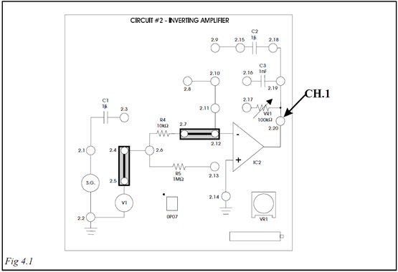

* Connect shorting links between sockets 2.4 & 2.5, and 2.7 & 2.12.
* Switch ON the Module Power Supplies.
* Set up the oscilloscope Timebase, channel 1 and 2 (set attenuation factor to 1 for BNC leads, with DC coupling) to display up to two complete cycles that fill the screen, both centred in the middle of the display. Adjust as necessary during the exercise.

|  |  |
| --- | --- |
| **D3000** | **Operational Amplifiers-1** |
| Laboratory Manual | **Chapter 4** |

There are no access points to the ±12V supplies on Circuit #2, but these can be monitored from Circuit #1.

* Use a BNC to 2mm connecting lead to connect CH.1 of the oscilloscope to socket 1.14 to monitor the +12V supply.
* Sketch the trace line on the graticule provided.

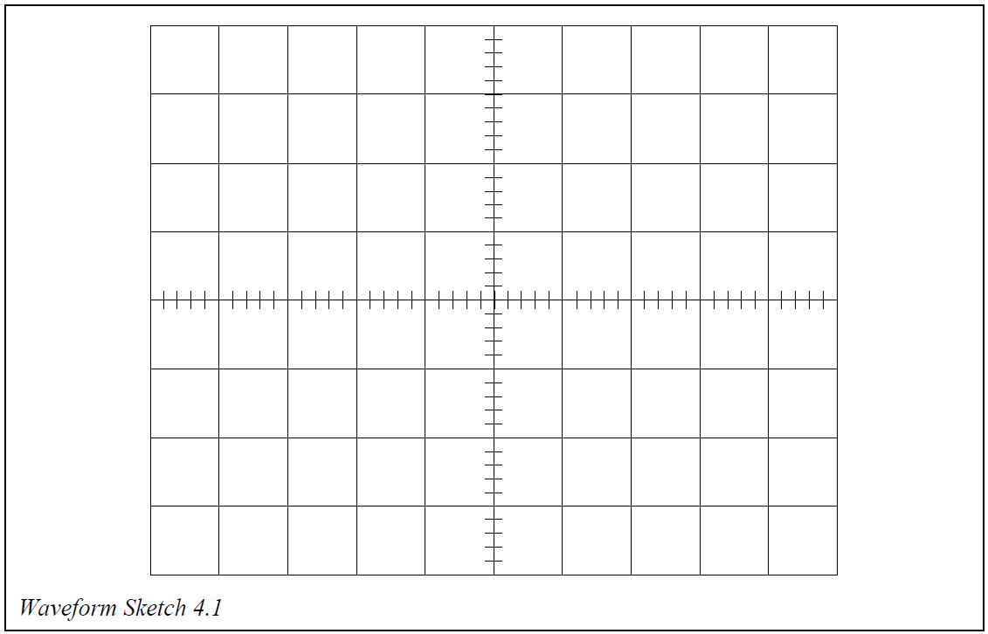

* Transfer the oscilloscope CH.1 BNC to 2mm connecting lead to socket 1.15 to monitor the -12V line and add this to your sketch.
* The remainder of this Exercise uses only Circuit #2.
* Transfer the oscilloscope CH.1 BNC to 2mm connecting lead to socket 2.20 to monitor the output of the amplifier.
* **Note: At the moment the amplifier is being operated in the open-loop mode, i.e. no feedback resistor, to ensure fast saturation**.
* Turn V1 (blue potentiometer on the right hand side of the board, **NOT VR1**) fully counter-clockwise to apply negative input to saturate the amplifier, positive going

|  |  |
| --- | --- |
| **D3000** | **Operational Amplifiers-1** |
| Laboratory Manual | **Chapter 4** |

* Add this trace line sketch to your others, on the same graticule.
* Turn V1 fully clockwise to apply positive input to saturate the amplifier, negative going.
* Add this trace line sketch also to your others, on the same graticule.
* Label each of the four trace lines so far drawn.
* Move the shorting link from between sockets 2.4 & 2.5 to 2.3 & 2.4, and add a further Link between sockets 2.11 & 2.17 to connect the feedback resistor.
* Set VR1 half way through its travel (arrow pointing upwards).
* Transfer the oscilloscope CH.1 BNC to 2mm connecting lead to socket 2.1 to monitor the input of the amplifier.
* Set the signal generator to 1kHz sinewave, and 10Vp-p, as seen on the oscilloscope. ()0.996kHz
* Add a further BNC to 2mm connecting lead to connect CH.2 of the oscilloscope to socket 2.20 to monitor the output of the amplifier.
* Sketch the waveform of the output on the same graticule as the supply and saturation levels previously recorded, taking care to preserve the voltage levels accurately.

Notice that the output signal is limited (clipped) at different levels in its positive and negative excursions.

* Reduce the signal input amplitude (signal generator amplitude control) and note that the positive peak loses its distortion first and then the negative, due to the different saturation levels.

Using your waveform sketches, answer the following questions.

**4.1a Enter the positive clipping level voltage of the output waveform. 5.12 voltsp-p**

V

**4.1b Enter the negative clipping level voltage of the output waveform. 4.48 voltsp-p**

V

|  |  |
| --- | --- |
| **D3000** | **Operational Amplifiers-1** |
| Laboratory Manual | **Chapter 4** |

# Exercise 4.2 Inverting Amplifier Gain and Bandwidth

Alternating signal gain is the same as for direct voltage inputs.

$A_{v}\text{=-}\frac{R_{f}}{R_{in}}$ with the minus sign denoting a signal inversion.

The **bandwidth** of an operational amplifier circuit is defined as the range of **frequencies over which the output voltage is greater than $\frac{1}{\sqrt{2}}x$** **the mid-band** output voltage.

The high and low frequencies at which the output voltage equals $\frac{1}{\sqrt{2}}x$**the mid-band** output voltage are known as the **upper limit frequency** and **lower limit frequency**.

The **gain-bandwidth product** of an op amp is a constant for a given device, and is quoted in the manufacturer’s datasheet for the IC. For the inverting amplifier circuit shown in Fig. 4.2 below, the upper limit frequency of the circuit’s bandwidth can be calculated if both the circuit gain, and the gain-bandwidth product of the op amp, are known. <https://www.analog.com/media/en/technical-documentation/data-sheets/op07.pdf>

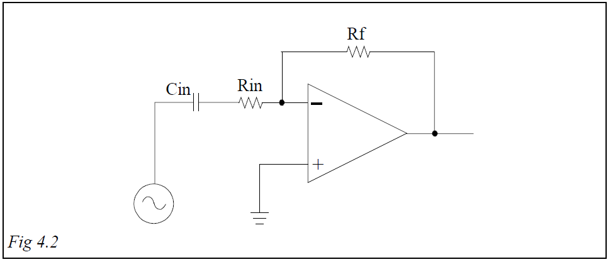

If the gain-bandwidth product is divided by the overall gain of the circuit, the result will be the upper limit frequency for the circuit’s bandwidth. A low circuit gain will therefore give a higher upper limit frequency than a high circuit gain.

For the circuit of Fig. 4.2, the lower limit frequency for the amplifier’s bandwidth will depend on the value of input capacitor Cin. The smaller the value of Cin, the higher will be the lower limit frequency of the circuit.

The upper and lower limit frequencies of an operational amplifier circuit will now be measured using Circuit #2

|  |  |
| --- | --- |
| **D3000** | **Operational Amplifiers-1** |
| Laboratory Manual | **Chapter 4** |

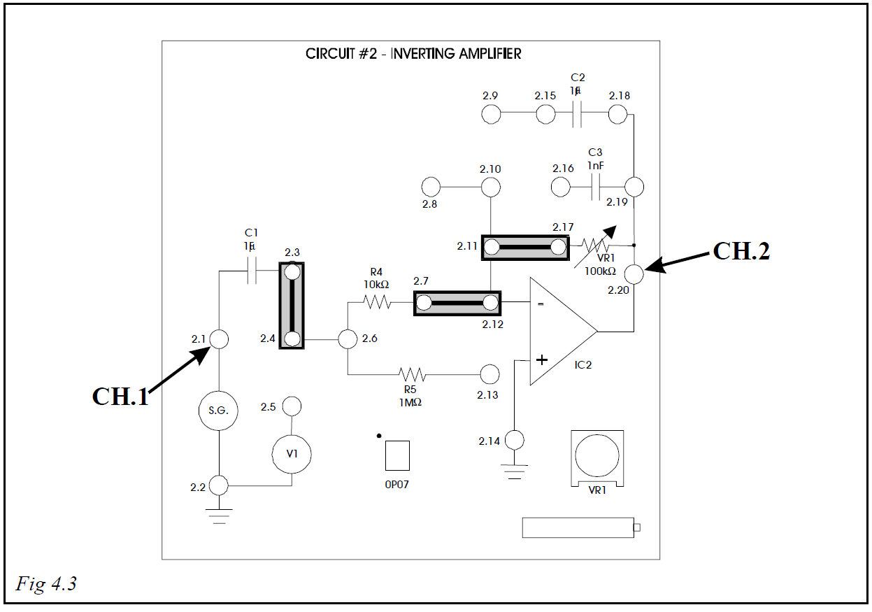

* Connect shorting links between sockets 2.3 & 2.4, 2.7 & 2.12, and 2.11& 2.17.
* Switch ON the Module Power Supplies.
* Set up the oscilloscope Timebase, channel 1 and 2 (set attenuation factor to 1 for BNC leads, with DC coupling) to display up to two complete cycles that fill the screen, both centred in the middle of the display. Adjust as necessary during the exercise.
* Use a BNC to 2mm connecting lead to connect CH.1 of the oscilloscope to socket 2.1 to monitor the input.
* Set the signal generator to 1kHz sinewave, minimum amplitude.
* Increase the input (signal generator amplitude control) to give an input voltage of 0.2V (200mV) p-p

|  |  |
| --- | --- |
| **D3000** | **Operational Amplifiers-1** |
| Laboratory Manual | **Chapter 4** |

* Use another BNC to 2mm connecting lead to connect CH.2 to socket 2.20 to monitor the output.
* Adjust VR1 to give an output of 0.8V (800mV)p-p.

Calculate the ratio of the amplitudes, $\frac{V_{out}}{V_{in}}$. This ratio is the magnitude of the gain Av.

$\frac{V_{out}}{V_{in}}=$ 0.808/0.198=4.08

**Bandwidth**

* Calculate the frequency limit voltage from the formula given earlier.

**Bandwidth limit voltage =**

mV p-p

565.69mV (70% of midrange voltage)

* Increase the frequency until the output voltage as seen on the oscilloscope falls to your calculated figure.

Ensure that the input voltage remains at 200mVp-p.

* Note the upper limit frequency.

**Upper limit frequency = 112.05**

kHz

The manufacturer’s stated gain-bandwidth product for the op-amp in Circuit #2 is 600kHz. Using this value and the value of circuit gain that you calculated earlier, calculate the Upper Limit Frequency of the circuit

**Calculated Upper Limit Frequency =**

147.06 kHz

* Compare this value with the value that you have just measured.
* Reduce the frequency (and Timebase) until the output voltage again falls to your calculated figure.

|  |  |
| --- | --- |
| **D3000** | **Operational Amplifiers-1** |
| Laboratory Manual | **Chapter 4** |

* Note the lower limit frequency.

**Lower limit frequency =**

Hz

18.639

* Reset the frequency of the input signal to 1kHz and the oscilloscope Timebase back to your initial settings
* Check from the oscilloscope that the waveforms are as originally instructed.
* Sketch the waveforms of the input and output voltages on the graticule provided, labelling each waveform with its peak-to-peak voltage.

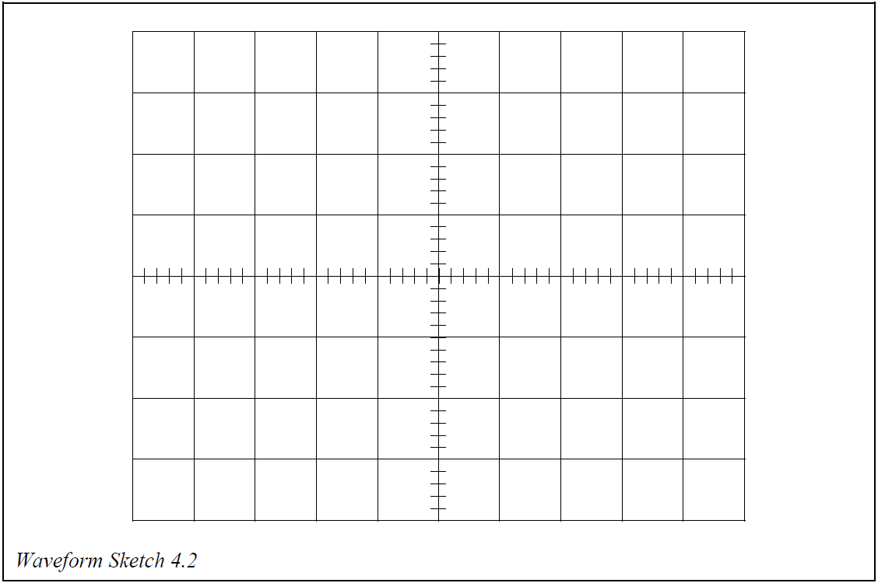

|  |  |
| --- | --- |
| **D3000** | **Operational Amplifiers-1** |
| Laboratory Manual | **Chapter 4** |

* Disconnect the oscilloscope 2mm connecting leads from the circuit.
* Connect the multimeter, set to the AC Voltage range to socket 2.20 (positive) and to socket 2.14 (common).
* Note and record the output signal voltage Vout in Table 4.1 as indicated on the multimeter.

|  |  |  |  |  |
| --- | --- | --- | --- | --- |
| Vout | Vin |  | VR1(Rf) |  |
| 0.271 V | 0.066 V | 4.11 | 41.62kΩ | 4.16 |
| *Table 4.1* |  |  |  |  |

* Transfer the multimeter positive lead to socket 2.1 to measure the input signal voltage Vin. Record in Table 4.1.
* Calculate the ratio of voltages $\frac{V_{out}}{V_{in}}$, and enter in Table 4.1. This ratio is the

magnitude of the gain Av.

**4.2d Enter your value of $\frac{V_{out}}{V_{in}}$**

* Remove the shorting link from sockets 2.11 & 2.17 to isolate the feedback resistor VR1 and measure its value with the ohmmeter range of the multimeter. Enter this also in Table 4.1.

Calculate the ratio of $\frac{R_{f}}{R_{in}}$, entering the result in Table 4.1. This ratio is also the magnitude of the gain Av.

**4.2e Enter your value of $\frac{R_{f}}{R_{in}}$**